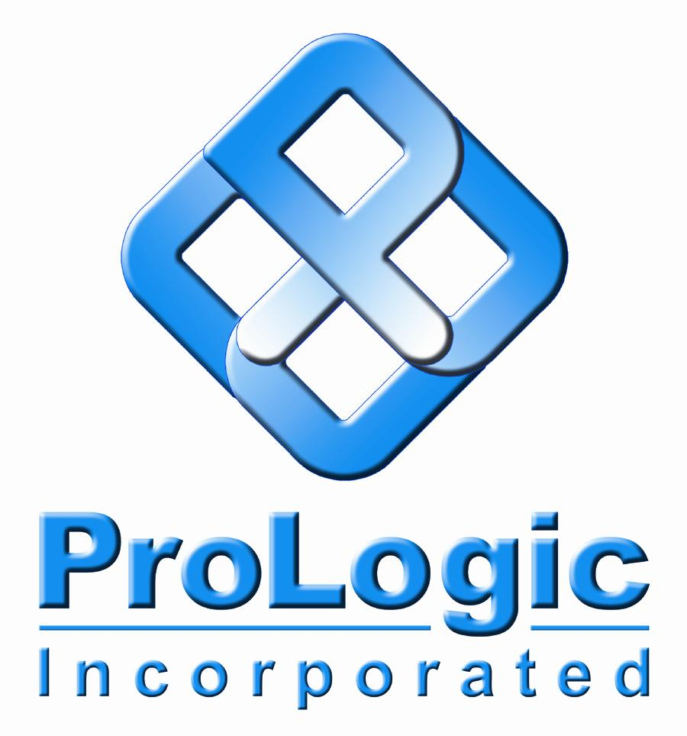

13th ICCRTS

“C2 for Complex Endeavors”
Title: Net-centric Collaboration and Situational Awareness with an Advanced User-Defined Operational Picture (UDOP)

Topics: 1, 7, 8, 9, 5

Authors: Jeremy Loomis, Rob Porter, Audie Hittle, Chetan Desai, Russ White

Point of Contact:

Audie Hittle

Vice President, Technology Applications

ProLogic Inc
Attn: Audie Hittle

1000 Green River Drive, Ste. 201

Fairmont, WV 26554

(978) 846-1632

ahittle@prologic-inc.com

Title: Net-centric Collaboration and Situational Awareness with an Advanced User-Defined Operational Picture (UDOP)

Abstract:

Historically, government and private sector organizations have developed “operations centers” as hubs for command and control functions. Over the past decade there has been significant interest in shared situational awareness and collaboration as well as improvement in networking capabilities of these organizations which has resulted in concepts and terms such as Common Operational Picture, Common Relevant Operational Picture, and User-Defined Operational Picture. These “pictures” signify the availability of operational information to an individual’s computing platform (outside the operations centers) to enable them to perform their function in support of command and control for their organization.

This paper defines and introduces the technology concepts for a User-Defined Operational Picture (UDOP), beyond the software prototype stage, that enable collaboration by providing visual situational awareness to end-users working within an operational Network-Centric environment that is offering an increasing number of web service-enabled information sources. These UDOP concepts are relevant for environments where information as well as end-users are connecting and collaborating over the network in support of operations. The UDOPs are created, visualized, augmented, tailored, and shared by the organization to enhance situational awareness and support collaborative and hierarchical decision-making. The UDOP architecture supports 2D, 3D, and 4D (3D + time) visualization using COTS technologies.

Some key technical challenges for implementing this UDOP capability include: support for dynamic and real-time information updates, peer-to-peer information sharing and collaboration, defining and sharing UDOP templates, and strategies for mapping across multiple data models. Implementation of a robust and flexible UDOP system relies on several key system design patterns that include Service Oriented Architecture (SOA), plug-in mechanisms, layer/filter models, and loose coupling. This paper will also describe one reference implementation of a UDOP system by reviewing an operationally deployed capability called Global Awareness Presentation Services (GAPS).

Key Words:

Network Centric, Net-Centric, Collaboration, Situational Awareness (SA), Common Operational Picture (COP), Common Relevant Operational Picture (CROP), User Defined Operational Picture (UDOP), View Creation, Visualization, Augmentation, Tailoring, Sharing, Decision-Making, 2D, 3D, 4D, Commercial Off-The-Shelf (COTS) Technology

Introduction and User Defined Operational Picture (UDOP) Definition

Recently, there is increased and significant interest in shared situational awareness and collaboration which stems from a growing awareness of the “art of the possible” and an improvement in networking capabilities. This interest and subsequent investment has resulted in the development and rapid evolution of concepts such as the User-Defined Operational Picture (UDOP). These user defined “pictures” signify the availability of delivering operational information to an individual’s computing platform, outside the traditional operations centers, enabling them to perform their function in support of command and control for their organization. So, at a high level, a UDOP has been defined as a “Decision-focused view of the operational environment that organizes disparate data sources to support accurate situational awareness (SA) and timely decision-making in a distributed net-centric environment [5]” (emphasis added).

Prior to UDOP, the concept of common operational picture (COP) and later common relevant operational picture (CROP) were commonly used. These terms and their successor, the UDOP term, are terms that progressively enable and empower the user with exposure to information that is needed to support decision making. The COP is a single/common picture of the activities and capabilities of the forces that affect a particular theater or mission. The information that describes these activities and capabilities to the user is available and accessible over the network. The CROP, on the other hand, provides customization of COPs to support the various groups of users (e.g., logistics vs. battle management). For each “group” of users, the operational picture is pre-defined and the access to relevant information is pre-configured. UDOP as the next concept in progression empowers the user to create their own operational picture by specifying the information (sources and filtering). UDOP provides the most flexibility to the use in creating an operational picture that help empowers her to perform the job. This UDOP can then be created, augmented, tailored, and shared with other users to create an environment that supports ad-hoc collaboration amongst the users.

The early work of developing a service oriented visualization framework (SOVF) [6] between 2000 and 2006 was a pre-cursor to the UDOP concepts described in this paper and focused primarily on technical concepts. SOVF created the framework largely based on the DoD guidance document on Net-Centric Data Strategy [reference] and NESI [reference]. SOVF described a core architectural framework that can provide the functionality for selection, filtering, transformation, stylizing, rendering, and updating of information for the user. UDOP for Tailored SA [5] provided a good discussion on relating the technical and operational contexts to more clearly identify the benefits of UDOP within an operational environment. The SOVF architectural framework was implemented under an R&D effort [reference] into a system called Global Awareness Presentation Services (GAPS) that is currently providing the majority of the UDOP functionality and capabilities discussed in this paper.

Hence, the UDOP becomes a key building block in the process of creating, visualizing, augmenting, tailoring and sharing of vital information. In fact, collectively, these processes represent the key UDOP objectives as collected from a particular user community which forms the basis for this paper. A brief description of each of these five UDOP objectives will help lay the foundation for the subsequent discussion on the definition of various UDOP architectural components. The basic objective of creating the UDOP includes the identification of content to be included or excluded for a specific user-defined picture. The visualization objective specifies how the selected content should be presented. Augmentation of the UDOP is an objective focused on deriving added-value based upon domain knowledge. The objective of tailoring the UDOP enables the adjustment of UDOP contents to address the needs of each user or echelon in the organization. Finally, the sharing objective includes the desired ability to conduct rich collaboration across a network-centric enterprise. These 5 objectives are consistent with readily available government architectures and they provide the guidance for UDOP software development in this rapidly evolving era of network-centric operations.

In addition to the above referenced architecture, a comprehensive literature search and review of related work has been accomplished. Many of the more relevant references are included in this report. Suffice it to say that this area of UDOP-based collaboration is perhaps one of the newest and most rapidly evolving areas of interest in the very dynamic environments associated with network-centric operations. The next section addresses many of the concepts and minimal essential definitions associated with this work. Subsequently, numerous use cases that exploit these concept definitions will be discussed and finally conclusions drawn regarding the current state of affairs and potential next steps.

While many challenges exist in bringing R&D architectures associated with UDOP and other advanced technologies into operational environments, efforts are underway to address them. In spite of best efforts, the challenges stemming from data stovepiping are still rampant. Other challenges, such as complex schemas which are difficult to normalize across systems and Communities Of Interest (COIs) and the rapidly changing (evolving) technologies and standards at all levels (SOA infrastructure, visualization, web applications, etc.), continue to plague nearly all operational environments. Specifically, some key technical challenges for implementing UDOP capabilities include areas such as: support for dynamic and real-time information updates; peer-to-peer information sharing and collaboration; defining and sharing UDOP templates; and strategies for mapping across multiple data models. Implementation of a robust and flexible UDOP system relies on several key system design patterns that include SOA, plug-in mechanisms, layer/filter models, and loose coupling. To help understand these challenges and potential solutions, this paper describes one reference implementation of a UDOP system by reviewing an operationally deployed capability called Global Awareness Presentation Services (GAPS). To achieve this, the GAPS architecture will be introduced and key concepts and terms will be defined to enable greater insight into the subsequent use cases discussed.

Architecture & Key Concepts

A viable architecture for accomplishing the UDOP objectives is shown in Figure 1. This architecture includes an Information Layer, Services Layer and Application Layer. For the purposes of this paper, the Information Layer presumes access to any/all desired sources of data is available in a web-enabled format, such as: relevant events provided through RSS feeds, operational tracks broadcast through event-based web services, imagery served via standards-based services (e.g., OGC WMS), and weather data made available via request-response web services.. However, it should be noted that in the still-maturing net-centric DoD enterprise, the discovery, identification and authorized access to the growing list of potential data sources presents its own technical and operational utility challenges. The Services Layer provides UDOP functionality such as: a UDOP repository for the storage of UDOP templates and derived products, stylization services to aid consistency in visual representations, automatic UDOP creation services to support machine-2-machine (M2M) transactions, and visualization adapters that can dynamically translate request for visual content (e.g., KML network links) into web-service call to web-enabled data sources. Finally the Application Layer provides the end-user interfaces for performing UDOP functions (authoring and consuming UDOPs), visualizing 2D/3D/4D UDOP-derived products, all in support of net-centric collaboration and performing operational tasks/decision-making.

Figure 1: UDOP Architecture

To fully appreciate the power and potential of this architecture, it is worth a few minutes to understand the architectural concept definitions. These components include the UDOP Template, Author/Viewer/Snapshots, Metadata, Aggregation, Peer-to-Peer Collaboration, Services, Data Types and Models, Data Normalization, Data Discovery and Retrieval, Potential uses of the Commercial Joint Mapping Toolkit (CJMTK), Information Assurance, and UDOP Services in the Global Information Grid (GIG).

UDOP Template (aka Recipe)
A UDOP Template (aka “recipe”) is used to define key elements for creating the picture, such as the base data, data sources, spatial filters, temporal filters, attribute filters, and symbology. Note that this template does not contain any retrieved data. There are various use cases that drive the creation of UDOPs: ranging from a standing UDOP (e.g., every day the user want to see the “same kind of picture” to support her daily tasks) versus ad-hoc environments (e.g., the user assembles a UDOP to help evaluate an emerging situation). UDOPs can also be set up for different time frames: planning, monitoring or after-action work flow. Just as it is an accepted procedure for one person to create a result or output of their work which is then used by others, UDOPs can likewise hierarchically feed other UDOPs as shown in Figure 2. To achieve maximum utility and flexibility, UDOPs need to be able to change during periods of collaboration and they should be able to be used in sequence during execution of a workflow.

UDOP Author, Viewer & Snapshots
A UDOP Author is used to create, tailor, augment and visualize UDOP Templates. It can be used to collaborate in a UDOP Session and can generate UDOP “Snapshots” (visualization products derived by “executing” the UDOP: retrieving data, filtering, and saving a fixed view) to quickly facilitate a common understanding. Components of the UDOP Template Viewer include the ability to visualize UDOP Templates using a flexible selection of common tools, such as the ArcGIS Explorer, AGI Viewer, or Google Earth. The ability to view and share the UDOP Templates creates an opportunity for collaboration in any given UDOP session. Likewise, the UDOP Snapshot Viewer can make use of common tools, such as a web browser or media player to view UDOP snapshots for a quick assessment.

Figure 2: Hierarchical nature of UDOPs

UDOPs Are Metadata-Rich
Metadata can include a wealth of information and it enables handling of the data pedigree to help define the authoritative source of the data. The metadata can also be used as a data quality indicator and metric of how “good” is this data. Additional uses include tags for data classification which identify who is allowed to see this data. Considerable new work is being done in this area, as it relates to FGDC CSDGM / ISO 19115 (or DDMS) Elements and efforts to use metadata for identification:

- access constraints (classification, releasibility)
- citation
- description
- spatial reference
- data quality (accuracy, completeness, lineage, etc.).

Aggregation
In our opinion, this is an overloaded term that can mean any one of many things, including UDOP Aggregation, UDOP Linking, Data Source Aggregation and Echelon Aggregation. Each of these terms is defined below to help clarify the potential ambiguity:

- UDOP Aggregation: This is the “addition” of UDOP templates: UDOP_{A} + UDOP_{B} = UDOP_{C}. It comes with its own unique challenges, such as what if User A wanted to see X and User B wanted to see Y?
- UDOP Linking: This involves the connection of UDOP_{C} “points to” UDOP_{A} and UDOP_{B}. Likewise, one linking challenge is how to maintain links as UDOP_{A} and UDOP_{B} change?
- Data Source Aggregation: This is intended to derive new data by combining/correlating existing sources/feeds. A challenge here is maintaining data model mapping, perhaps similar to Yahoo Pipes, which likely requires a “man-in-the-loop” type of operational procedure.
- Echelon Aggregation: This enables the collapse/expansion of compound entities (units/ formations/ etc.). It is likely driven by defined factors such as a specific user profile (strategic/tactical) or by navigation (near/far).

Peer-to-Peer Collaboration
When it comes to getting things done, it’s been said that “no man is an island” and certainly no organization, no matter how large or small, is able to go it alone. Collaboration is the key to getting the job done right and Peer-to-Peer collaboration holds some of the biggest potential for leveraging shared information and perspectives. A UDOP system should provide Geo- and Time- enabled versions of core collaboration techniques such as whiteboard and chat., as well as other social networking techniques like virtual presence, rooms and sessions. UDOP-specific collaboration concepts include: shared annotations, shared templates, shared organic data, shared workflow and dynamically linked views, as envisioned in Figure 3.

Figure 3: Depiction of UDOP Collaboration Techniques

UDOP Services
These services parallel the five core UDOP objectives mentioned earlier, that is the creation, visualization, sharing, aggregation and collaboration associated with this network-centric operating environment. In this case, the UDOP services are defined as follows: Creation services assist the author clients in creating/editing/tailoring UDOPs. These services also offer high-level automatic UDOP generation. The visualization services, including symbology and rendering, enable centralized stylization and symbol generation. Sharing services such as storage and discovery leverage the UDOP repository of UDOP Templates available for browsing, previewing, loading, and modifying. Aggregation services support the server-side UDOP aggregation process and provide transformation services for data source aggregation. Finally, collaboration services can be either asynchronous via UDOP repository access, or synchronous via advanced peer-to-peer mechanisms.

Data Types and Models
For the purposes of this paper, data “types” refers to a wide variety of data including: base data, maps and imagery, vectors (cities, roads, rivers, regions, etc.), vector overlays, a selection of user documents such as Air Tasking Orders, Modernized Integrated Database (MIDB) facilities and equipment, Geo-events, weather, satellites, tracks, and other relevant annotations. Concepts for modeling geospatial data include applications of geometry, 2D/3D coordinate systems, terrain information, features, topology, use of images, grid, temporal entity, sensor collection, spatial index, bi-temporality, areas/volumes, level-of-detail and whole-earth techniques.

Data Normalization
This can be an extremely challenging and somewhat subjective area to work in. There are a few well known rules for doing data normalization, including elimination of repeating groups and redundant data. In addition, from a data organization perspective, attributes that do not directly contribute to a particular description can be eliminated (or moved to an alternate location). Finally, rules associated with efforts to isolate independent multiple relationships and semantically related multiple relationships need to be addressed.

Across the spectrum of data model normalization design patterns there are the two extremes of “single schema” and “no normalization”. The single schema is a model that effectively creates a master language that is easy for providers, but is hard for consumers of the data to know or guess at the language. At the other extreme of “no normalization”, experience shows that this does not scale well and leads to a loss of efficiency. Somewhere in the middle of this spectrum is a model that allows normalization by “data family”. This can include normalization based upon families of data, such as imagery, possibly using NITF, GeoTIFF, etc.; tracks using Cursor on Target (CoT); Features using GML; Weather using JMBL, GRIB, etc., and satellites using TLE. However, more than just the data entities may need to be normalized to produce an effective and efficient environment for operations. Items such as queries, subscriptions, notifications, and result codes represent examples of these entities. Likewise, there are numerous perspectives and standards to be to be addressed in the normalization, including provider and consumer perspectives as well as Geospatial, Command and Control (C2), WMS, WFS, GML, GeoRSS, CoT, KML, C2IEDEM, TENA, SEDRIS, and C2 Core Schema to name a few. The data normalization must address core attributes, such as location, time, and affiliation to enable even basic access and use.
Figure 4: Data Normalization Challenge

Data Discovery & Retrieval
Data discovery typically refers to a process in which data in an electronic form is sought and the source located. Retrieval extends the data discovery process to the next logical step, which is to acquire the data and return it to the intended user or customer. When working in a Services Oriented Architecture (SOA) framework, the concept of data discovery is extended the relevant services as part of a Service Discovery process. Increasingly, information about such services is included in the metadata (or data about the primary data), which can be stored as content in repositories, such as the DoD Metadata Repository. High-level services, such as those provided by the Network Centric Enterprise Services (NCES), include the Universal Description, Discovery and Integration (UDDI) capability, which is a platform-independent, Extensible Mark-up Language (XML)-based registry for organizations to publish service listings enabling service (data) discovery and potential reuse of the services. Data Delivery Protocols are defined which describe how the data must be prepared and presented if it is to be reused by other services or applications. Additional related concepts include Web Services (addressing the data retrieval concepts of push/pull, publish/subscribe, REST, etc.), RSS, Sockets, File Transfer protocols (e.g., e-mail, FTP, HTTP, etc.) play an important role in data discovery and retrieval. Likewise, the concept of Streaming Data, presents an entirely new set of challenges that push today’s protocols and technologies to their limits. In addition, a variety of subscription concepts, such as filters, time-limited constraints, cookies and expiration begin to play a role in the discovery and timely retrieval of data. Hence, the concept of notification mechanisms plays an important part in the effective use of newly identified/discovered data. Polling is another concept that can be used to attempt to discover new or updated data. Asynchronous callback, to a web service endpoint, is another technique enabling access to and retrieval of data, just as messaging (JMS, MSMQ, etc.) and e-mail can be used. Gateways represent a solution for gaining access to networks and data when there is no direct link or common language between the requestor and source of the data. Without fail, the growth of networking and data repositories leads to the potential for network and consumer overload. Whether such overload is driven by bandwidth constraints, network latency issues, or complexities associated with multiple NRT clocks, the ability to discover and retrieve data is affected and will continue to present numerous challenges to researchers and development teams for years to come.

Presentation Tier
Probably the most critical elements of any C2 visualization architecture, at least as far as the end-user is concerned, are the visualization clients themselves. These clients represent the software and hardware packaging in the presentation tier that provide the operator with the user interface with which he will access data and business logic used in performing C2 functions. There are two ways to characterize visualization clients: 1) by their role, either service consumer or author/producer; and 2) by the size of their software/hardware “footprint.” Table 1 shows the typical relationships between the client’s roles and their footprint. The shaded circles depict the degree of compatibility between the client roles and footprints.

Visualization  Client  Characteristics | Service Consumer | Author / Producer
Rich Client
Hybrid Client
Thin/Web Client
Table 2-1 Client Characteristics Relationships
Legend
Compatible
Somewhat compatible
Not compatible

Client Roles
- Service consumers display information using variety of user interface methods, tables, trees, editors, and geospatial displays.
- Author/Producers generally also display information in a variety of ways, but require richer, more data-intensive software applications to support their authoring capabilities.
Client Footprints
- Rich clients rely on local processing and storage, and are usually capable of more graphics-intensive and data-driven displays.
- Thin or Web clients are those that use neither local processing nor storage. Applications on these clients use products like JavaScript or AJAX to interact with an application server to provide the display.
- Hybrid clients generally download software components, such as applets, from the server and perform some local processing. They may have a minimal installation but often do not use local storage.

Technologies Overview
For the purposes of this UDOP project, a visualization technology agnostic approach has been taken to provide the most flexibility and to explore which technologies may be most relevant or of greatest utility to this user community. Some of these visualization technologies include CJMTK (ArcGIS), AGI STK, Falcon View, Google Earth, and Virtual Earth. Several of these technologies are described below to provide some appreciation for these presentation tier capabilities.

ArcGIS and CJMTK
ArcGIS is a Geographic Information System (GIS) system produced by Environmental Systems Research Institute, Inc. (ESRI) which includes various components applicable to and useful for Command and Control applications. These components include:

- ArcGIS Desktop – A suite of applications that display maps, surfaces, features, coverages and other GIS data in a visually rich environment. It manages and integrates GIS data, performs advanced analysis, models and automates operational processes and displays results.
- ArcGIS Engine (ArcObjects) – a core software GIS library which enables development of software solutions in various languages. Included are technologies supporting display and interaction of maps and feature overlays, as well as data processing extensions. 3D Analyst and Spatial Analyst are two examples of data processing extensions.
- ArcGIS Explorer – a free application which displays and shares information geographically.
- ArcGIS Server – an integrated server-based GIS solution that provides applications and services for spatial data management, visualization, and spatial analysis.
- ArcGIS Image Server – a management, processing, and distribution platform for geospatial imagery that integrates with ArcGIS Server. It provides fast and open access to geospatial imagery.
- ArcIMS – a server-based product which provides web publishing of maps and other GIS data. Clients that consume ArcIMS data can be mobile, desktop, or browser-based.
- MapObjects Java Edition (MOJE) – provides pure Java GIS and mapping components that allow developers to build custom, cross-platform mapping and spatially enabled applications.
- Military Overlay Editor (MOLE) – provides a framework and full support for Department of Defense (DoD) MIL-STD 2525B and NATO's APP6a specifications. MOLE allows you to easily create, display, and edit military symbology in your maps. It enhances the effectiveness of your command and control (C2) and mission applications by combining the spatial analysis capabilities of ArcGIS with common war fighting symbology.

The ArcGIS product line offers up a powerful set of applications for storage, analysis and mapping of geospatial data. The selection of the products will vary depending on what the intended visualization system will be. For example, custom C2 desktop applications may take advantage of the ArcGIS Engine product to provide a framework for managing and visualizing C2 data, one may choose ArcSDE to house geospatial data in an enterprise data repository, ArcIMS or ArcGIS Server can be used to surface C2 data through web services for either desktop applications or thin clients running in a web browser.

ArcGIS provides an extensive GIS analytical capability in which C2 data can be used to perform advanced computations (e.g. intercept calculations, line of sight, e.g.) ArcGIS products provide a great deal of native support for a variety of data formats including those provided by NGA (e.g. CADRG, DTED, etc.) ArcGIS offers some support for open standards like OGC but the structures are fairly restricted in terms of what is able to interact with the applications. The architecture also provides a significant amount of flexibility to developers in terms of application customization. Developers can provide new format support either through raster/feature plug-ins or custom layers. ArcGIS also supports C2 data visualization with products like Military Overlay Editor (MOLE) which provides 2525B support. MOLE offers a fairly extensive set of capabilities for generating/rendering tactical graphics. MOLE usage does come at the expense of reduced application performance and increased resource usage (i.e. processor/memory).

ArcGIS products generally only run under a Windows based platform. While some components exist with Java or Linux support these products typically represent a wrapping of the Windows product to enable some operation with Java or Linux. These cross-platform products are relatively new and perhaps are less stable than the pure Windows counterparts. Cross-platform solutions may be better filled by thin clients served up by a Windows server.

AGI
Analytical Graphics Incorporated (http://www.agi.com) brings a suite of technologies that are applicable to the C2/SOA/Visualization domain. Key technologies that can be used as a software component in a larger C2/SOA/Visualization system are their 4DX and Dynamic Geometry (DGL) libraries. DGL is a powerful class library built on version 2.0 of the Microsoft .NET platform. The DGL component technology enables users to create a variety of solutions with a modern development paradigm; from small utilities used to process proprietary data to desktop aerospace software applications, multi-user web applications, or a piece of a service-oriented architecture (SOA). Dynamic Geometry Library (DGL) is the base library of AGI’s component technology and provides high-precision modeling of time and coordinate frames for accurate orbit and waypoint propagation of satellites, aircraft, ground vehicles and their sensors. Additionally, DGL includes numerical methods, and geometry transformation algorithms, which users can use to compute position, orientation, and intervisibility intervals for many platforms and missions.
The 4DX and DGL libraries provide the following specific capabilities for globally accurate 4D (3D + time) visualization: time; coordinates, rotations, accurate earth, moon and planet modeling; earth axes, geometry transformation engine; complex numerical algorithms, orbit propagation algorithm; waypoint propagation; sensor geometry modeling; intervisibility access; and platform modeling (various satellites, facilities, aircraft, etc.).
AGI library technologies can be used as building blocks to provide visualizations that operate within a variety of clients as illustrated in Figure and Figure below.
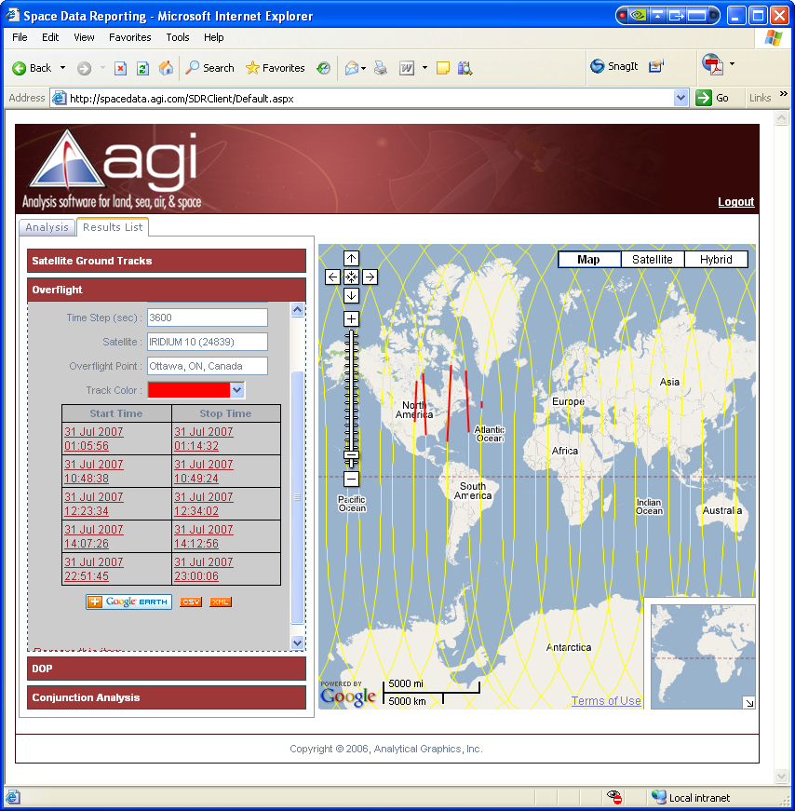
Figure 5: Web client accessing a web service built
using DGL with results drawn on Google Map
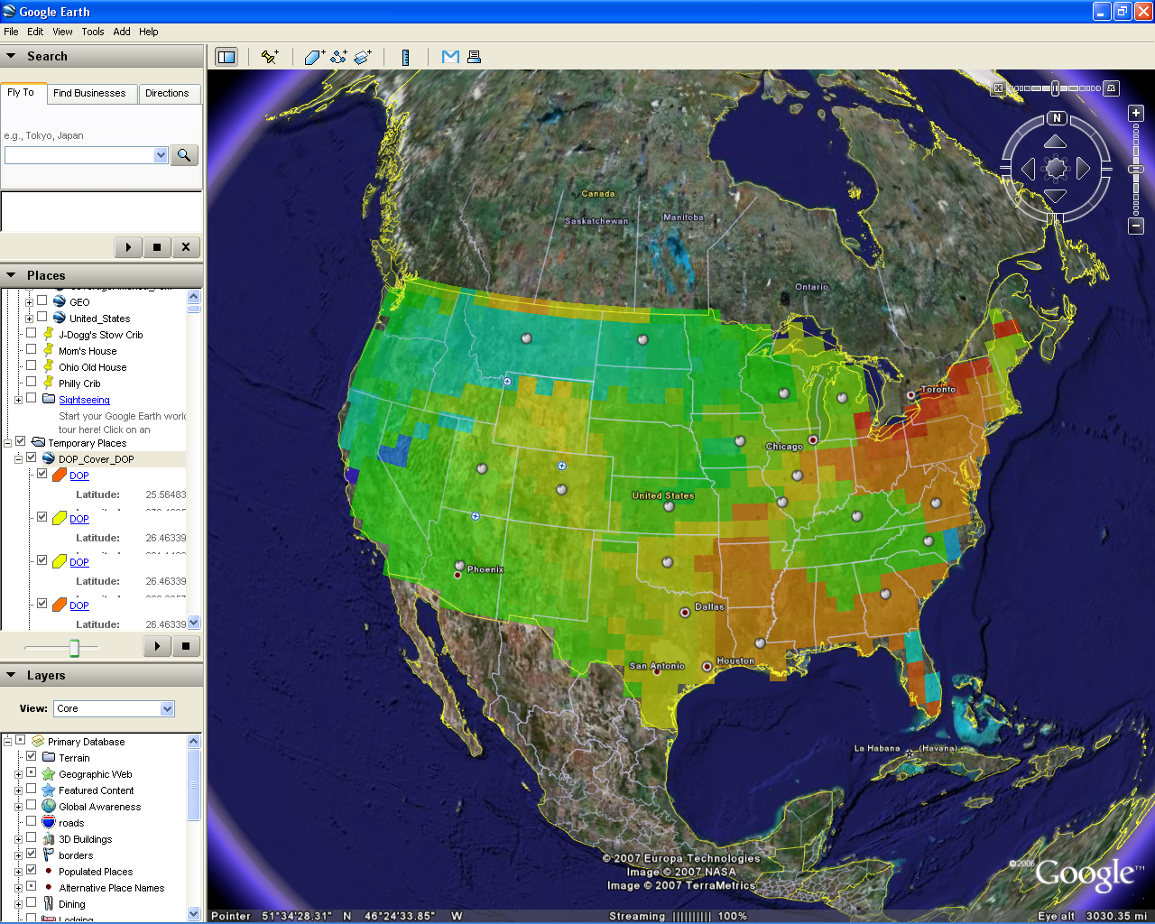
Figure 6. STK GPS Dilution of Precision (DOP) analysis shown in GoogleEarth

The AGI products can also provide four dimensional (three geospatial dimensions plus time) visualization of assets. This can aid C2 decision making by providing time varying, geospatial visualization of planned or near real time location information for various assets, overlays (such as clouds), etc.

The DGL library can be used to integrate the computational power of AGI even without the corresponding AGI visualization technology. This advantage can be seen in the figure below where DGL component technology is used to integrate satellite propagation and imaging opportunity computations into the ESRI ArcMap product via an ArcGIS extension.

Figure 7. AGI DGL ArcGIS Extension Showing Imaging Opportunities
for Selected Global Sites within the ESRI ArcMap Application

This ArcGIS extension, called Satellite and Sensor Analyst can be used to add temporal layers of satellite and sensor analysis to a geospatial view. These layers can be analyzed against other feature classes to:
- Determine imaging opportunities from satellite/sensor to areas of interest.
- Calculate communication intervals between a satellite and GIS features.
- Generate custom reports detailing exact times and durations of when selected GIS features can be “seen” by satellites or sensors.

This allows the DGL enhanced ArcMap tool to provide essential decision support capabilities within the GIS environment. The extension allows one to:
- Generate historical, real-time, or predictive satellite data
- Import any satellite from the AGI Satellite Database (including commercial imaging, communications, and GPS satellites)
- Add new satellites to the database
- Store calculations as custom feature classes that can be analyzed against any other GIS feature class
- Define sensor parameters
- Perform area of interest analysis and visualize results
- Display and animate ground track/sensor projections in ArcMap

AGI products can also be used to develop SOA solutions by using the 4DX and/or DGL libraries to support web services methods to provide analysis via SOA. For example, these libraries could be used to provide a web method that requires a target location, a satellite identifier (such as the NORAD SSC number), and a planning period (such as the next two days). The libraries could then be used to compute coverage time periods where the line of sight between the target and the satellite is above ten degrees elevation. The web service could then return these coverage time periods. Another example would be a web application using an SOA web service back end that requires a start date, an end date, a time step, a satellite, and a trace color. The web application could then map the ground track of the chosen satellite in Google Maps. The figure below shows a notional user interface for such an example.

Another advantage of the AGI products is highly accurate time varying coordinate transformations, including transformations between terrestrial coordinate systems and inertial coordinate systems. This includes accounting for nutation, pole wander, and leap seconds which vary over time and affect terrestrial to inertial coordinate system transformations. These transformations are not as critical when dealing with terrestrial assets such as facilities, ships, airplanes, and ground vehicles. However, when dealing with space based objects such as satellites, the proper transformation of these coordinates is crucial.

In terms of detractors, the standalone STK application does not lend itself directly to an SOA. As noted above, however, the 4DX and DGL libraries can be used to support SOA. In addition to the 4DX and DGL libraries, AGI has developed the Satellite Toolkit. Satellite Toolkit (STK) is a COTS analysis technology. The STK/X control is the main three-dimensional portion of the STK toolkit. STK/X is a control for global visualization. It allows for changing perspective, line-of-sight calculations, sun lighting. The STK/X control is time aware; in that sense, it can be described as offering four-dimensional visualization.

The AGI/STK/4DX/DGL paradigm is to provide physics based object modeling and visualization of missiles, ground vehicles, ships, facilities, aircraft, satellites, sensors, transmitters, receivers, and radars. Using the 4DX/DGL libraries, applications can be developed in C, C++, C# .net, VB, VB .net, etc. The sophisticated STK Geometry Engine can compute azimuth and elevation angles in a coordinate frame between objects, angle rates, range, range rates, radar performance, communication link performance, etc.

The AGI tools can perform predictive computation of absolute values of and “constraint” satisfaction time periods for the following types of mission objectives: geometric, proximity, pointing, lighting, line-of-sight atmospheric conditions, inter-object geometry, communication link quality, radar performance measures, terrain vertical profiles, etc. This predictive computation can include determination of “multi-constraint” satisfaction times.

Google Earth
Google (http://www.google.com/about.html) is the creator of Google Earth, a thick client, net-centric earth visualization tool that is applicable to the C2/SOA/Visualization domain. Google Earth combines satellite imagery, maps, terrain, and 3D buildings to put the world’s geographic information at your fingertips.
- Fly to any location on earth. Just type in an address, press Search, and you’ll zoom right in.
- Search for geographic features, sports venues, transportation terminals, hospitals, and more. Get driving directions.
- Tilt and rotate the view to see 3D terrain and buildings, or look up to explore the sky
- Save and share your searches and favorites.

The following diagram describes some of the features available in the main window of Google Earth:

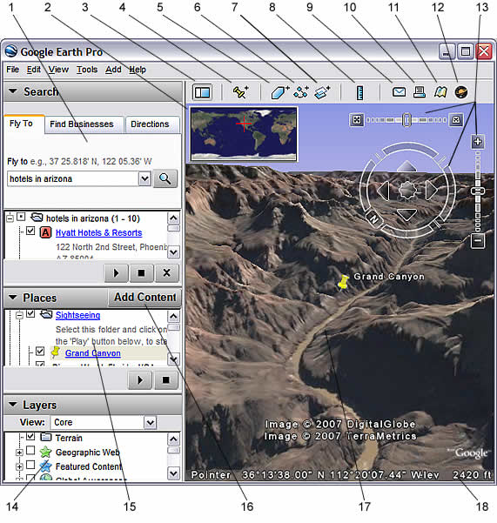
Figure 8. Illustration of a Google Earth Display

- Search panel - Use this to find places and directions and manage search results. Google Earth EC may display additional tabs here.
- Overview map - Use this for an additional perspective of the Earth.
- Hide/Show sidebar - Click this to conceal or the display the side bar (Search, Places and Layers panels).
- Placemark - Click this to add a placemark for a location.
- Polygon - Click this to add a polygon.
- Path - Click this to add a path (line or lines).
- Image Overlay - Click this to add an image overlay on the Earth.
- Measure - Click this to measure a distance or area size.
- Email - Click this to email a view or image.
- Print - Click this to print the current view of the Earth.
- Show in Google Maps - Click this to show the current view in Google Maps in your web browser.
- Sky - Click this to view stars, constellations, galaxies, planets and the Earth's moon.
- Navigation controls - Use these to tilt, zoom and move around your viewpoint (see below).
- Layers panel - Use this to display points of interest.
- Places panel - Use this to locate, save, organize and revisit placemarks.
- Add Content - Click this to import exciting content from the KML Gallery
- 3D Viewer - View the globe and its terrain in this window.
- Status bar - View coordinate, elevation and imagery streaming status here.

There are numerous considerations when determining whether to use Google Earth for a C2/SOA/Visualization solution.

The pros for using Google Earth are as follows. First, Google Earth supports network links. These can be used in an SOA manner as clients to an SOA service that returns KML.

Another pro to using Google Earth is that it is a free visualization client. In addition, the base imagery and map data is also streamed to the Google Earth viewer as long as the viewer is on a machine connected to a network where Google Imagery servers reside (e.g., the Internet or SIPRNET).. The streaming of this data is geospatial context dependent. That is, less detailed data is streamed when the viewer is zoomed out and more detailed data is streamed when the viewer is zoomed in. In addition, when the viewer is zoomed in only the detailed data that is in the viewers field of view is streamed to the viewer.

An additional advantage of Google Earth is the native support for the Keyhole Markup Language (KML) format. All aspects of the KML format are supported.

Another advantage of Google Earth is ease of navigation. It is straightforward to move around the earth and zoom in and out. A more difficult navigational concept which Google Earth incorporates is the ability to reorient north to up, which is a natural view for most people. An enhancement that would be nice would be for Google Earth to offer a mode where North is locked in the up direction on the screen. Finally, Google Earth offers good support for “tilting” the view. This allows the viewer to not just have a nadir view of the Earth, but also more oblique angle views of the earth.

A final advantage of Google Earth is its support for automatic de-cluttering. On some occasions, the user may be viewing data that has two geospatial features such as points that overlap each other. In this case one point occludes the other; or in some cases it could occlude many other features. Google Earth provides the ability to click on the occluding point. It then separates the multiple points, but adds lines pointing to their actual geospatial location. In this way all the points with their labels can be viewed at once.

A disadvantage to using Google Earth is that it does not support time varying data. That is, it cannot animate the geospatial visualization over a time period and show geospatial objects such as airplanes moving from one place to another. Alternative methods of rendering must be used such as showing complete flight paths. It has, however, been noted that in recent versions of Google Earth there has been the addition of a time slider control containing a sliding time window that might be used in the future to support visualization of time dynamic geospatial data.

Two final cons associated with Google Earth are 1) there is no client-side API set, and 2) there are serious concerns over display performance with several thousand objects plotted.

Information Assurance
The U.S. Government's National Information Assurance Glossary (CNNS Instruction No. 4009) defines IA as the “ Measures that protect and defend information and information systems by ensuring their availability, integrity, authentication, confidentiality, and nonrepudiation. These measures include providing for restoration of information systems by incorporating protection, detection, and reaction capabilities.”

Information Assurance (IA) is generally recognized as the practice of identifying, monitoring and managing information-related risks with a goal of protecting the availability, confidentiality, and integrity of relevant data and it’s respective data-delivery systems. Information Security and IA are closely related and the terms are frequently used interchangeably. IA, however, is typically a broader term that addresses the more strategic nature of risk management versus the more narrowly defined information security which is primarily drawn from and relates to the field of computer science. In addition, IA can include numerous aspects of corporate governance and is an interdisciplinary field that spans military science, systems engineering, forensic science, as well as computer science, management science and others.

This section will present a high-level overview of key concepts such as security, HTTPS, SSL, certificates, PKI/PKE, CAC, WS-Security and classification. In addition, relevant UDOP IA concepts such as tracking of data pedigree (when the UDOP pulls data from many systems), handling of security labels and dissemination codes (CAPCO) as well as monitoring, capturing and usage of metrics will be discussed.

UDOP Services in the GIG
This section will present an overview of the key concepts associated with the Global Information Grid (GIG) and the increasing use of UDOP services as currently deployed in such systems as the Global Awareness Presentation System (GAPS). According to the National Security Agency (NSA) website, the “Global Information Grid (GIG) vision implies a fundamental shift in information management, communication, and assurance.” The GIG system will provide authorized users with a seamless, secure, and interconnected information environment, meeting real-time and near real-time needs of both the warfighter and the business user. The GIG will use commercial technologies augmented to meet DoD's mission-critical user requirements. Reference (http://www.nsa.gov/ia/industry/gig.cfm). The UDOP services will build upon and complement the transformation communications services that already exist to support the GIG, such as the discovery, storage, security and mediation services. The UDOP Services, described further in some of the following Use Cases, include such things as UDOP Creation, Collaboration, Analysis, Data Adapters, Symbology and Data Loader Services.

Use Cases
This section describes eleven UDOP use cases as they are currently defined in the operational GAPS solution. Each use case will help to introduce further concepts and insight as to the use and functions of the UDOP technology.

A. Personal UDOP for Situational Awareness
The first step in this process involves creating a new empty UDOP Template with the Author Application and GUP (recipe file). The process continues with Step 2 and the selection of data sources, for instance from the Globes and Tracks servers. Then, if desired additional data can be selected from a local or personal organic data source. This step concludes by going to an analysis service, such as the AGI or ESRI servers for weather impacts or mission plans. Step 3 involves selecting the customizing template viewer option and may involve the selection of ArcGIS Explorer, AGI Viewer, or Google Earth, depending on the user’s needs. Step 4 proceeds with the retrieval of data sources from the services and the application of filters to the data, such as the use of symbolization preferences like MIL-STD 2525B. Step 5 is the interactive viewing of the UDOP with the Author Application 4D display. And Step 6 involves saving the UDOP Template with references to the local data, filters, symbolism choices, etc. This final Personal UDOP then includes all the information related to MIDB, routes, GIS, country borders, weather forcast, etc. selected for personal use or subsequent sharing.

B. Sharing UDOP Templates
In this process, the User X Creates a blank UDOP Template with Author Application as a GUP file. The User X generates various UDOP snapshots by defining which data sources to use with which template viewers. Then, this information, including Snapshots and Templates is written to the UDOP Repository (for storage and subsequent discovery) in the GAPS Server. At this point User Y enters and accesses the UDOP Author Desktop Application to search or discover relevant information in the UDOP Repository. Upon discovery, User Y opens the UDOP Template in the Author Application and then views the interactive UDOP with the Author Application 4D Display, thus sharing the template and information created earlier by User X.

C. Asynchronous Collaboration
In Use Case C, User X creates a blank UDOP template using the Author App. Then User X generates snapshots, using the processes previously noted. User X publishes those snapshots to the UDOP Repository and subsequently blogs about the UDOP to a DoD portal manually through a browser or automatically via their UDOP Author Application, and this blog reference is also entered into the UDOP Repository. User Y discovers and then reads about the UDOP through the portal. Once discovered, User Y can then retrieve the UDOP Template as previously described under the “Sharing UDOP Templates” capability. This is one type of asynchronous collaboration, but collaboration could also occur through e-mail or other established mechanisms.

D. Mixed Visualization Environments
In the Mixed Visualization Environment scenario, User X Creates the UDOP using the Author Application as before. Likewise, various snapshots are generated from a selection of data sources and viewers and stored in the UDOP Repository. User Y then discovers the snapshots by browsing/searching the repository. Once discovered, User Y consumes the snapshots with relevant viewers, media players, browsers, etc. In addition, User X distributes the snapshots directly via e-mail to User Z who then “discovers” the snapshots by simply receiving/opening the email without first having to go to the snapshot viewers (browser, medial players, etc.). Then, User Z consumes the snapshots by using their choice of viewers on the files. This approach supports a full range of end-user environments, including disadvantaged clients.

E. Direct Visualization Adapters
In this scenario, The User adds a new Network Link between a viewer and a GAPS service. Then, the user specifies the feed URL with query parameters. When the network link is refreshed, the adapter provides the new Keyhole Markup Language (KML) reference. Given the network link, the user accesses a data loader to connect to a relevant data source or sources. Once connected, the adapters transform the data item into KML for subsequent viewing via Google Earth which adds the KML to a data tree. This has the advantage of using a lightweight software layer for data transformation and the data is virtually guaranteed to be up-to-date. The disadvantage, however, is that if done without a memory cache, the process always incurs a transformation delay and there’s an increased load on the backend data service.

F. UDOP Aggregation
Not to be confused with UDOP aggravation, in the UDOP Aggregation scenario, the User Searches UDOP Repository for Snapshots/Templates to aggregate. Then a parameter of aggregation is specified as part of a UDOP Creation Service in the GAPS server. Once done, a combined UDOP Template is generated and UDOP snapshots depicting the aggregation are generated. Next, the UDOP templates/snapshots are published back to the UDOP Repository and optionally the aggregated UDOP is published to the DoD Portal. Once prepared, the aggregated UDOP is then available for personal or collaborative team use.

G. Automatic M2M Generation
In this scenario, the DoD Portal has new geospatial content due to the recent entry of a new event by User X or due to a database update. Subsequently, the portal calls the UDOP Creation Service with a High-Level request. Given the event, the GAPS server Creation Service creates a detailed UDOP Template which is then used by the Creation Service to generate UDOP snapshots. Then, the template and snapshots are published to the UDOP Repository and a link to the UDOP is sent back to the Calling Portal. It is then possible for User Y to review the UDOP by following the Portal link and viewing the snapshots stored in the Repository with their choice of browser, media player or template viewer.

H. Peer-to-Peer Collaboration
For the Peer-to-Peer collaboration scenario, User X opens the UDOP Authoring Application and initiates a collaboration session in the UDOP Services layer. User X then invites Users Y and Z (via phone, email, external chat) to join the session. Users Y and Z subsequently open the UDOP Authoring Application and join the session. During the session, the collaborating parties can use chat via text, share data, views, annotations, and whiteboard activities. Optionally, users can archive the collaboration session for subsequent reference or review.

I. Streaming Data
The User locates a Streaming Data Source via the Author Application in this scenario. The, the user configures a filter for the streaming data source. Next, the user initiates a subscription to the streaming data source with the appropriate notification mechanisms. Once established, the application receives notification messages from the streaming data source and the application dynamically updates the display to reflect the steaming data.

J. Thin Client UDOP Authoring
In this scenario, the user is accessing the thin client UDOP Author Web Site which provides similar Functionality as the UDOP Author Desktop Application. As with the application, the thin client can be used to create, tailor and visualize UDOP templates. In addition, the Author Web Site can be used to load UDOP templates from the Repository or to publish UDOP Templates or snapshots to the Repository. The Author Web Site thin client uses the UDOP Creation Service to create Snapshots as in the application, however, a primary difference is that thin client uses a 2D display versus the 3D display of the Author Desktop Application. There is also limited support of interaction and animation.

K. Batch Processing
As implied, the GAPS Batch Processor runs scheduled batch tasks. A Batch Task will connect to data services as needed. The Batch Task will also create or update a UDOP Template as needed. Batch Tasks will support UDOP snapshots and will publish UDOOP template/snapshots to the Repository. As with individual tasks or efforts, Batch Tasks can send notifications, for instance on a SKIWEB event or blog, as needed. Finally, a user can subsequently review the UDOP by following a portal link and using the snapshot or template viewers to see and use the snapshots.

Conclusion
The concept of a User Defined Operational Picture or UDOP is rapidly becoming a key building block in the process of creating, visualizing, augmenting, tailoring and sharing of vital operational information. Collectively, these five processes represent the key UDOP development objectives and, as collected from a particular user community, formed the basis of this paper. This paper defined and introduced the collaboration technology concepts for a UDOP, beyond the software prototype stage, by providing visual situational awareness to end-users working within an operational Network-Centric environment that is offering an increasing number of web service-enabled information sources. These UDOP concepts are relevant for environments where information as well as end-users are connecting and collaborating over the network in support of operations.

Some key technical challenges for implementing this UDOP capability have included: support for dynamic and real-time information updates, peer-to-peer information sharing and collaboration, defining and sharing UDOP templates, strategies for mapping across multiple data models. Implementation of a robust and flexible UDOP system relies on several key system design patterns that include Service Oriented Architecture (SOA), plug-in mechanisms, layer/filter models, and loose coupling. This paper also described one reference implementation of a UDOP system by reviewing an operationally deployed capability called Global Awareness Presentation Services (GAPS).

Selected References
- Alberts, D. S., Garstka, J. J., and Stein, F. P. 1999. Network Centric Warfare, Washington, DC: Command and Control Research Program.
- Alberts, D. S., and Hayes, R. 2006, Understanding Command and Control. Washington, DC: Command and Control Research Program.
- Alberts, D. S., and Hayes, R. 2003. Power to the Edge. Washington, DC: Command and Control Research Program.
- USAF Electronic Systems Center. 2005. Strategic Technical Plan v2.0, Hanscom AFB: USAF Electronic Systems Center, Available online at ttp://herbb.hanscom.af.mil/hot_buttons/STP/ESC_STP_v2_0_PR.pdf.
- Mulgund, S., and Landsman, S. 2006. User Defined Operational Pictures for Tailored Situational Awareness. 12th International Command and Control Research and Technology Symposium section: page#-page#.
- ProLogic, Inc. 2005. Technical Roadmap for Developing a Service-Oriented Visualization Framework. Prepared for USAF Electronic Systems Center, Hanscom AFB.
- Desai, C. J. 2005. Net-centric Temporal / Geospatial Visualization, Presented at the C2 Visualization Industry Day hosted by the C2 Battlelab, Langley, VA.
- Loomis, J. J., and White, R. 2006. Global Awareness Presentation Services, Presented at the C2 Summit, Hosted by USSTRATCOM, Omaha, NE.
- Department of Defense. 2003. Department of Defense Net-centric Data Strategy. Washington DC: DOD, Available online at http://www.defenselink.mil/cio-nii/docs/Net-Centric-Data-Strategy-2003-05-092.pdf.
- USAF Electronic Systems Center. 2005. Net-centric Enterprise Solutions for Interoperability (NESI), Hanscom AFB: USAF Electronic Systems Center, Available online at http://nesipublic.spawar.navy.mil/.

